**Ideation Phase**

**Assessing the safety of Municipal drinking water & Idea Prioritization Template**

| Date | 06 May 2023 |
| --- | --- |
| Team ID | NM2023TMID19072 |
| Project Name | Assessing the safety of Municipal drinking water |
| Maximum Marks | 4 Marks |

**Assessing the safety of Municipal drinking water & Idea Prioritization Template:**

Background

In low resourced countries, water-associated diseases have still impact on public health. Poor quality of water can cause waterborne diseases through bacteria, viruses, protozoa, and parasites that has been responsible for millions of morbidity and mortality. Therefore, this study aimed to assess quality and safety of public municipal drinking water in Addis Ababa City.

Methods

Descriptive epidemiological study design that used quantitative approach was carried out at Addis Ababa City Administration from June 2016 to October 2016. Pre-tested and standardized aseptic samplecollection technique was utilized to collect a total of 2976 samples (2951 water samples for bacteriological analysis by Presence-Absence (P-A) culturing method and 25 samples for parasites identification through direct microscopy examination). Descriptive data were summarized and cleaned by the SPSS version 20 software and presented in table and graph.

Result

The study revealed that 10%, 7% and 3% were positive for bacteriological, total coliforms, and fecal coliforms respectively through Presence-Absence Broth test. The bacterial distribution trends from 1st to 13th weeks of wet season were slight increment of total coliforms and slight decrement for fecal coliforms. All tested for parasitological samples from selected reservoirs were free from parasitological species.

Step1: Technical

Water quality is a critical issue that affects both human health and the environment. Our project aims to assess water quality in a specific region by examining various physical, chemical and biological parameters. We have collected water samples from different locations and measured parameters such as pH, Hardness, dissolved solids, chloramines, conductivity, sulfates, organic carbon, trihalomethanes, turbidity and potability.

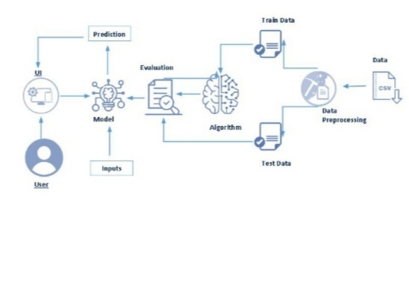

**Step-2: climate change water quality**

Widespread, rapid, and intensifying climate change plays an important role in drinking water quality. By scientifically exploring the interrelated mechanisms between climate change and drinking water quality, professionals can better adapt and optimize the water management and thereby ensure drinking water safety. Here, a new concept regarding water quality under the conditions of climate change is proposed due to the potential long-time and far-reaching impacts.

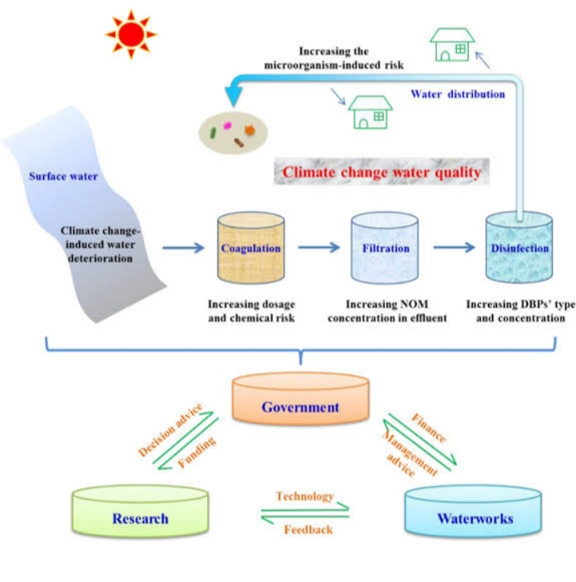

**Step-3: assessing the safety of Municipal drinking water & Idea Prioritization**

